Graduation Portrait Sessions for
Port Moody Secondary

November 22 - 27, 2011


Reserve your portrait session now by clicking “book session”
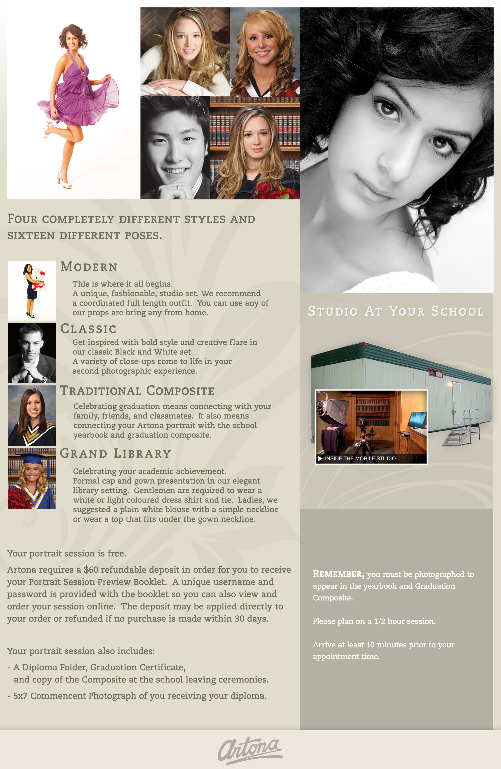
WWW.ARTONAGROUP.COM

